NAME _______________________________CLASS______ ADM NO. ………..

**2022 FORM 4 TERM 1 OPENER EXAM- (APRIL 2022)**

**232/1**

**PHYSICS**

**PAPER 1**

(THEORY)

TIME: 2 HOURS

INSTRUCTIONS TO CANDIDATES

1. The paper consists of two sections, Section **A** and **B**.
2. Answer **ALL** the questions in section A and B in the spaces provided.
3. **ALL** answers andworking **MUST** be clearly shown.
4. Mathematical tables and electronic calculators **may be** used.

**SECTION A** (25 MARKS)

***Answer ALL the questions in this section in the spaces provided.***

1. A micrometer screw gauge is used to measure the thickness of a stuck of 10 microscope slide cover slips. The reading with the cover slips in position is as shown in figure 1.

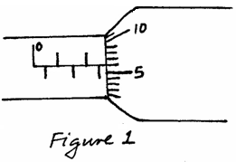

If the micrometer screw gauge has a negative zero error of 0.01mm, determine the thickness of each cover slip. (2 marks)

____________________________________________________________________________

____________________________________________________________________________

____________________________________________________________________________

____________________________________________________________________________

2.Explain briefly why water will wet a glass surface but mercury will not. (2 **marks**)

____________________________________________________________________________________________________________________________________________________________________________________________________________________________________________________________________________________________________________________________________________

3. The figure below is that of a uniform meter rule supported at the 30cm. A load of 5N is attached at

the 0cm mark and that of 2N to a pulley at the 100cm mark. Calculate the weight of the meter rule. (3 **marks**)

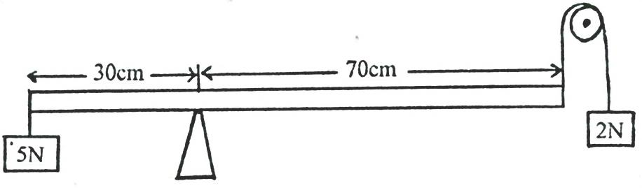

4. A mercury barometer reads 75cmHg at the base of Mt.Kenya. Assuming that the height of

the mountain is 1088m and the average density of air is 1.25kg/m3. What is the reading of the

barometer at the top of the mountain? (Take density of mercury is 13.6g/cm3.) (3 **marks**)

1. The figure below is a rectangular block in a stable equilibrium, with a hollow section as shown. 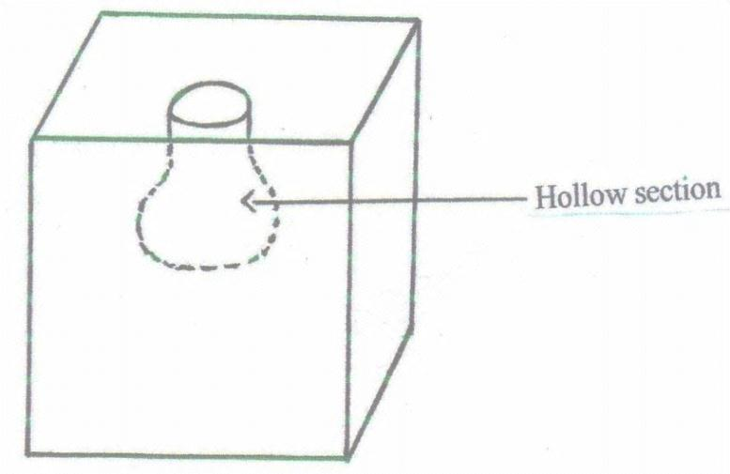

**Hollow section**

1. What is the effect of adding water into the hollow section? (1 **mark**)

______________________________________________________________________________________________________________________________________________________________________

1. What could be the reason for your answer above? (2 **marks**)

______________________________________________________________________________________________________________________________________________________________________6. The figure below is that of identical springs. A 60N weight is attached on the springs as shown

so that the total extension for the system is 6cm. Calculate the spring constant of one spring. (3 **marks**)

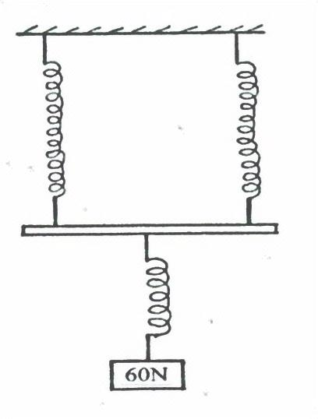

**60N**

6.The system in the figure below is in equilibrium at room temperature. The system is taken

outside where the temperature is 100C higher for some time.

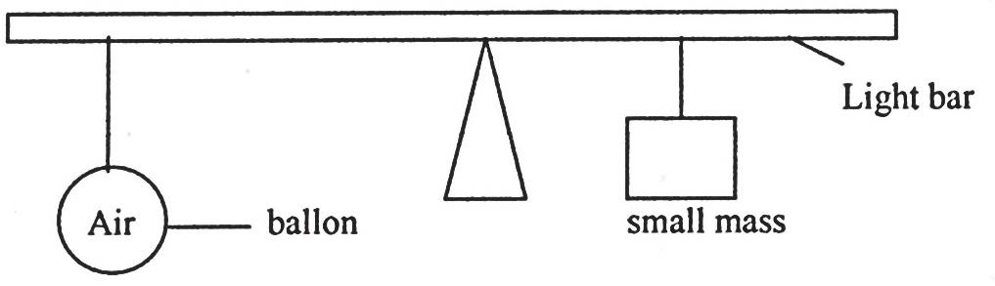

**Balloon**

**Small mass**

**Light bar**

Explain why it tips to the right when it is taken outside the room. (2 **marks**)

____________________________________________________________________________________________________________________________________________________________________________________________________________________________________________________________________________________________________________________________________________

1. State **one** way of increasing sensitivity of mercury in glass thermometer. (1 **mark**)

______________________________________________________________________________________________________________________________________________________________________

1. A tightly fitted bottle cork will be easier to remove if the bottle is warmed.

Explain this using kinetic and thermal property of matter. (2 **marks**)

____________________________________________________________________________________________________________________________________________________________________________________________________________________________________________________________________________________________________________________________________________

1. A bullet of mass 20g moving with a velocity of 30m/s penetrates a sand bag and it’s brought

to rest in 0.05 seconds. Find the average retarding force of the sand. (3 **marks**)

1. Explain why an iron gate feels colder when touched but its wooden gatepost feels warm at night. (1 **mark**)

_________________________________________________________________________________________________________________________________________________________________________________________________________________________________________________________

**SECTION B (55 MARKS)**

***Answer ALL the questions in this section in the spaces provided.***

1. a) Distinguish between streamline and turbulent flow. (2 **marks**)

____________________________________________________________________________________________________________________________________________________________________________________________________________________________________________________________________________________________________________________________________________

b) The figure below shows two light sheets of paper arranged as shown.

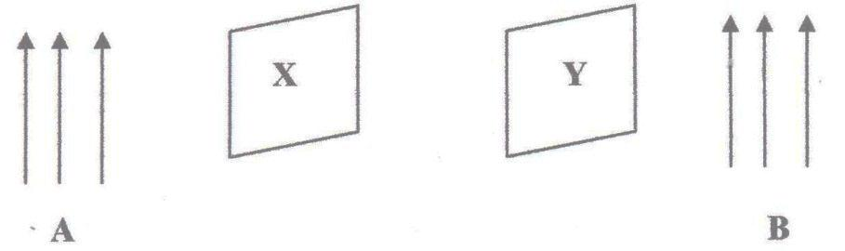

**Y**

**X**

**B**

**A**

Explain the observation made when air is blown at the same speed and time at points A and B. (2 **marks**)

_________________________________________________________________________________________________________________________________________________________________________________________________________________________________________________________

1. The figure below shows an incompressible fluid moving through a tube of varied cross- sectional area. If the area of the small tube is 0.05m2, calculate the diameter of the large tube in cm. (3 **marks**) 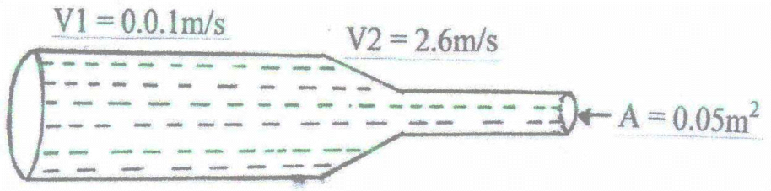

**V1 = 2.6 m/s**

**A = 0.05 m2**

**V1 = 0.01 m/s**

1. Use the figure below to answer the questions that follow.

**Gas in**

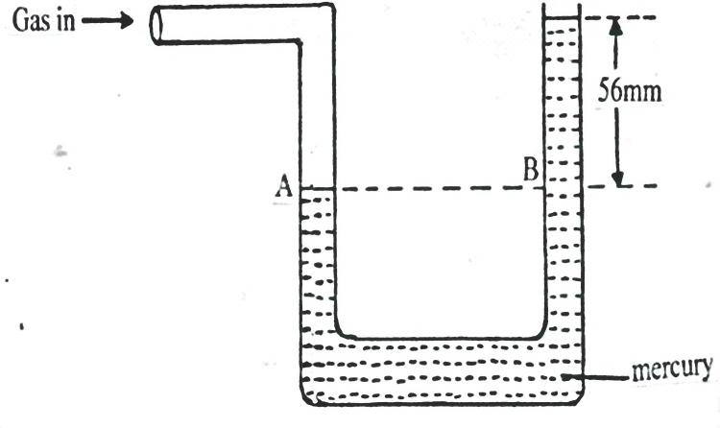

**56mm**

**B**

**A**

**Mercury**

1. What pressure is acting on point A? (1 **mark**)

___________________________________________________________________________________

1. What is the value of pressure difference in the instrument reading? (1 **mark**)
2. If the atmospheric pressure is 760mm of mercury, what is the value of gas pressure? (2 **marks**)
3. In an experiment to estimate the size of oil molecule an oil drop of diameter 0.05cm spreads over

water to form a circular patch whose diameter is 15cm.

a) Explain why the oil spreads over water. (1 mark)

______________________________________________________________________________________________________________________________________________________________________

b) Determine:

i) Volume of the drop. (3 marks)

ii) Area of the patch. (3 marks)

c) State **two** assumptions made in b)(ii) above. (3 marks)

___________________________________________________________________________________

______________________________________________________________________________________________________________________________________________________________

13. The figure below shows a velocity – time graph for the motion of a certain body.



Describe the motion of the body in the region:

1. OA: (1 **mark**)

______________________________________________________________________________________________________________________________________________________________________

1. AB: (1 **mark**)

______________________________________________________________________________________________________________________________________________________________________

1. BC: (1 **mark**)

______________________________________________________________________________________________________________________________________________________________________

b) A car moving initially at 10m/s decelerates at 2.5m/s2

Determine:

1. I) Its velocity after 1.5seconds. (2 **marks**)

II) distance travelled in 1.5 seconds. (3 **marks**)

1. The time taken for the car to stop. (3 **marks**)
2. Sketch the velocity – time graph for the motion of the car up to the time the car stopped. (1 **mark**)
3. From the graph determine the distance the car travelled before stopping. (2 **marks**)

14. a) A machine is a device that enables work to be done more easily and conveniently. State any two ways in which a machine makes work easier. (2 marks)

……………………………………………………………………………………………………………………………………………………………………………………………………………………………………………………………………………………………………………………………………………………………………………………………………………………………………………………………………………………………………………………………………………………………………………………………………………………………………………………

b) Figure 7 shows a wheel and axle being used to raise a load W by applying an effort E. The radius of the wheel is R and of the axle is r.

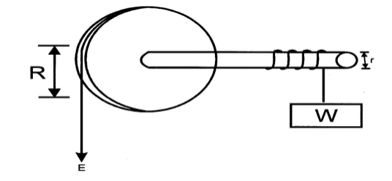

i) Show that the velocity ratio (V.R) of this machine is given by  (3 Marks)

………………………………………………………………………………………………………………………………………………………………………………………………………………………………………………………………………………………………………………………………………………………………………………………………………………………………………………………………………………………………………………………………………………………………………………………………………………………………………………………………

ii) Given that r = 5cm and R = 50cm, determine the effort required to raise a load of 200N if the efficiency of the machine is 90%. (3 mks)

………………………………………………………………………………………………………………………………………………………………………………………………………………………………………………………………………………………………………………………………………………………………………………………………………………………………………………………………………………………………………………………………………………………………………………………………………………………………………………………………

(C). State two reasons the efficiency of any given machine less than 100% (2mks)

15. (a) State Hooke’s Law. (1mk)

…………………………………………………………………………………………………………

…………………………………………………………………………………………………………

(b) The figure below shows the variation force with extension for a steel coil spring.

(i) On the same axes, sketch the variation of force with extension for a wire from which the spring

**Force N**

**Extension cm**

is made. (1mk)

ii). Explain the difference between the two lines drawn (2mks)

…………………………………………………………………………………………………………

………………………………………………………………………………………………

(iii) The following results were obtained in a experiment to verify Hooke’s law when a spring was

extended by hanging various loads on it.

|  |  |  |  |  |  |  |  |
| --- | --- | --- | --- | --- | --- | --- | --- |
| Load (N) | 0.00 | 1.00 | 2.00 | 3.00 | 4.00 | 5.00 | 6.00 |
| Length of spring in cm | 10.00 | 11.50 | 13.00 | 14.50 | 16.00 | 18.00 | 24.00 |
| Extension | 0.00 |  |  |  |  |  |  |

Complete the table for the extension e above. (1mk)

(iv) Plot a graph of load (y-axis) against extension (3mks)

(v) From the graph determine the springs constant. (2mks)